**Run a custom container in Azure**

* Article
* 12/02/2021
* 9 minutes to read
  + [](https://github.com/msangapu-msft)
  + [](https://github.com/cebundy)
  + [](https://github.com/alexbuckgit)
  + [](https://github.com/cephalin)
  + [](https://github.com/pallabiwrites)
  + +6

Is this page helpful?

Top of Form

Choose a custom container platform

Linux containerWindows container

Bottom of Form

**In this article**

1. [Prerequisites](https://docs.microsoft.com/en-us/azure/app-service/quickstart-custom-container?tabs=dotnet&pivots=container-windows#prerequisites)
2. [Create an ASP.NET web app](https://docs.microsoft.com/en-us/azure/app-service/quickstart-custom-container?tabs=dotnet&pivots=container-windows#create-an-aspnet-web-app)
3. [Publish to Azure Container Registry](https://docs.microsoft.com/en-us/azure/app-service/quickstart-custom-container?tabs=dotnet&pivots=container-windows#publish-to-azure-container-registry)
4. [Create a Windows custom container](https://docs.microsoft.com/en-us/azure/app-service/quickstart-custom-container?tabs=dotnet&pivots=container-windows#create-a-windows-custom-container)
5. [Browse to the custom container](https://docs.microsoft.com/en-us/azure/app-service/quickstart-custom-container?tabs=dotnet&pivots=container-windows#browse-to-the-custom-container)
6. [See container start-up logs](https://docs.microsoft.com/en-us/azure/app-service/quickstart-custom-container?tabs=dotnet&pivots=container-windows#see-container-start-up-logs)
7. [Update locally and redeploy](https://docs.microsoft.com/en-us/azure/app-service/quickstart-custom-container?tabs=dotnet&pivots=container-windows#update-locally-and-redeploy)
8. [Next steps](https://docs.microsoft.com/en-us/azure/app-service/quickstart-custom-container?tabs=dotnet&pivots=container-windows#next-steps)

[Azure App Service](https://docs.microsoft.com/en-us/azure/app-service/overview) provides pre-defined application stacks on Windows like ASP.NET or Node.js, running on IIS. However, the preconfigured application stacks [lock down the operating system and prevent low-level access](https://docs.microsoft.com/en-us/azure/app-service/operating-system-functionality). Custom Windows containers do not have these restrictions, and let developers fully customize the containers and give containerized applications full access to Windows functionality.

This quickstart shows how to deploy an ASP.NET app, in a Windows image, to [Azure Container Registry](https://docs.microsoft.com/en-us/azure/container-registry/container-registry-intro) from Visual Studio. You run the app in a custom container in Azure App Service.

**Prerequisites**

To complete this tutorial:

* [Install Docker for Windows](https://docs.docker.com/docker-for-windows/install/).
* [Switch Docker to run Windows containers](https://docs.microsoft.com/en-us/virtualization/windowscontainers/quick-start/quick-start-windows-10).
* [Install Visual Studio 2022](https://www.visualstudio.com/downloads/) with the **ASP.NET and web development** and **Azure development** workloads. In *Visual Studio 2022 Community*, ensure **.NET Framework project and item templates** component is selected with **ASP.NET and web development workload**. If you've installed Visual Studio 2022 already:
  + Install the latest updates in Visual Studio by selecting **Help** > **Check for Updates**.
  + Add the workloads in Visual Studio by selecting **Tools** > **Get Tools and Features**.

**Create an ASP.NET web app**

Create an ASP.NET web app by following these steps:

1. Open Visual Studio and then select **Create a new project**.
2. In **Create a new project**, find and choose **ASP.NET Web Application (.NET Framework)** for C#, then select **Next**.

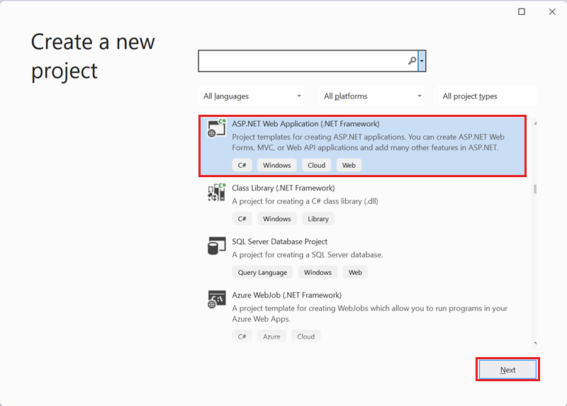

1. In **Configure your new project**, under **Project name**, name the application *myfirstazurewebapp*. Under **Framework**, select **.NET Framework 4.8** and then select **Create**.

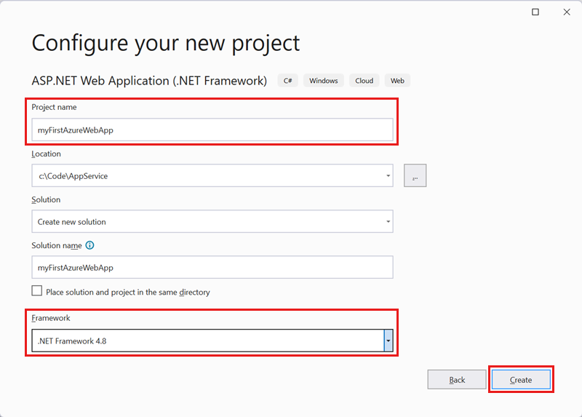

1. You can deploy any type of ASP.NET web app to Azure. For this quickstart, choose the **MVC** template.
2. Under **Authentication**, select **None**. Under **Advanced**, select **Docker support** and uncheck **Configure for HTTPS**. Select **Create**.

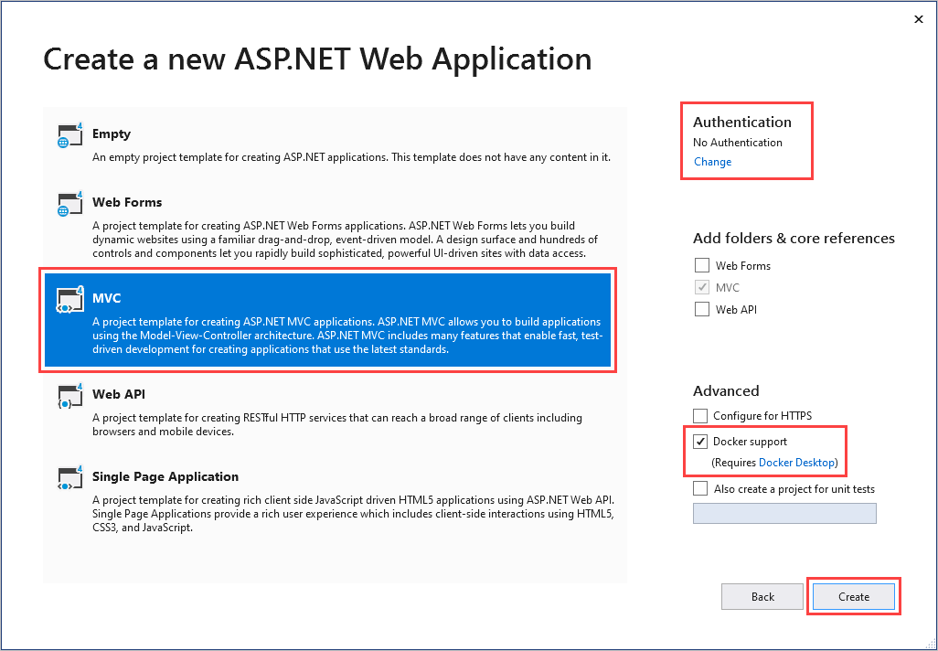

1. If the *Dockerfile* file isn't opened automatically, open it from the **Solution Explorer**.
2. You need a [supported parent image](https://docs.microsoft.com/en-us/azure/app-service/configure-custom-container#supported-parent-images). Change the parent image by replacing the FROM line with the following code and save the file:

DockerfileCopy

FROM mcr.microsoft.com/dotnet/framework/aspnet:4.8-windowsservercore-ltsc2019

1. From the Visual Studio menu, select **Debug** > **Start Without Debugging** to run the web app locally.

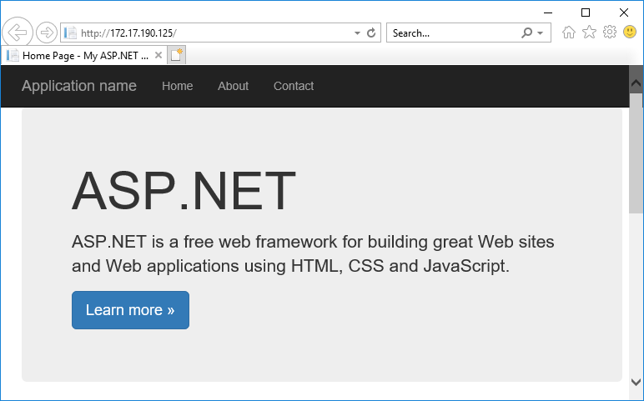

**Publish to Azure Container Registry**

1. In **Solution Explorer**, right-click the **myfirstazurewebapp** project and select **Publish**.
2. In **Target**, select **Docker Container Registry**, and then click **Next**.

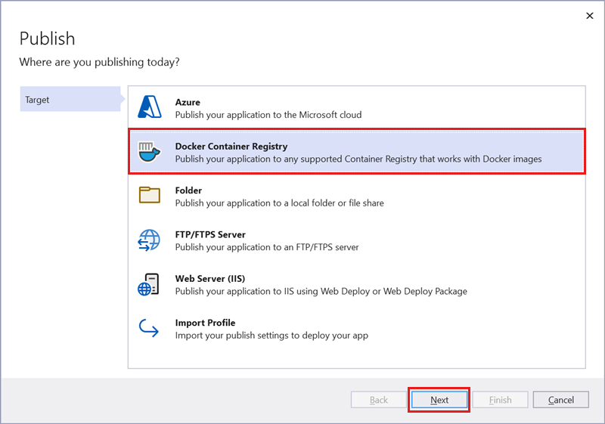

1. In **Specific Target**, select **Azure Container Registry**, and then click **Next**.

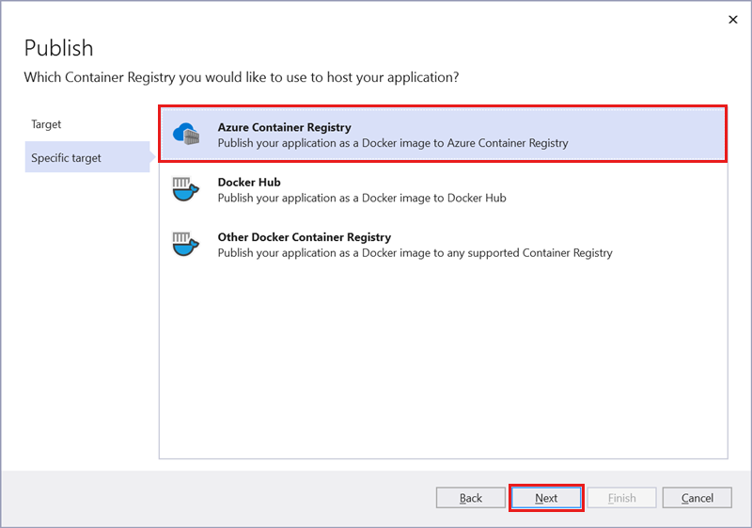

1. In **Publish**, make sure the correct subscription is chosen. In **Container registries** select the **+** button to create a new Azure Container Registry.

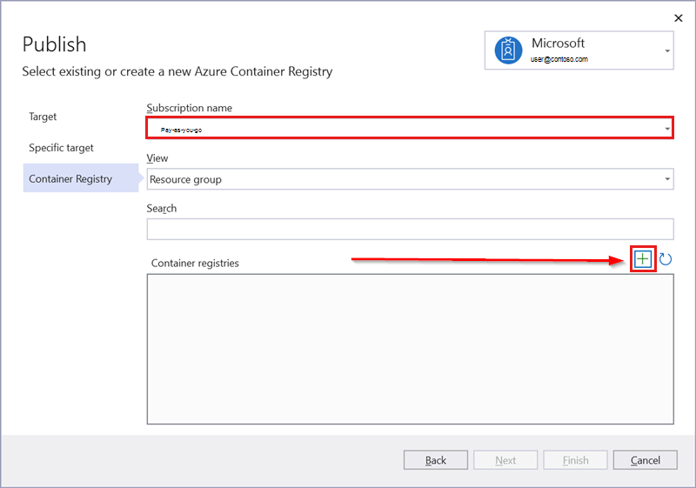

1. In **Create new**, make sure the correct subscription is chosen. Under **Resource group**, select **New** and type *myResourceGroup* for the name, and click **OK**. Under **SKU**, select **Basic**. Under **Registry location**, select a location of the registry then select **Create**.

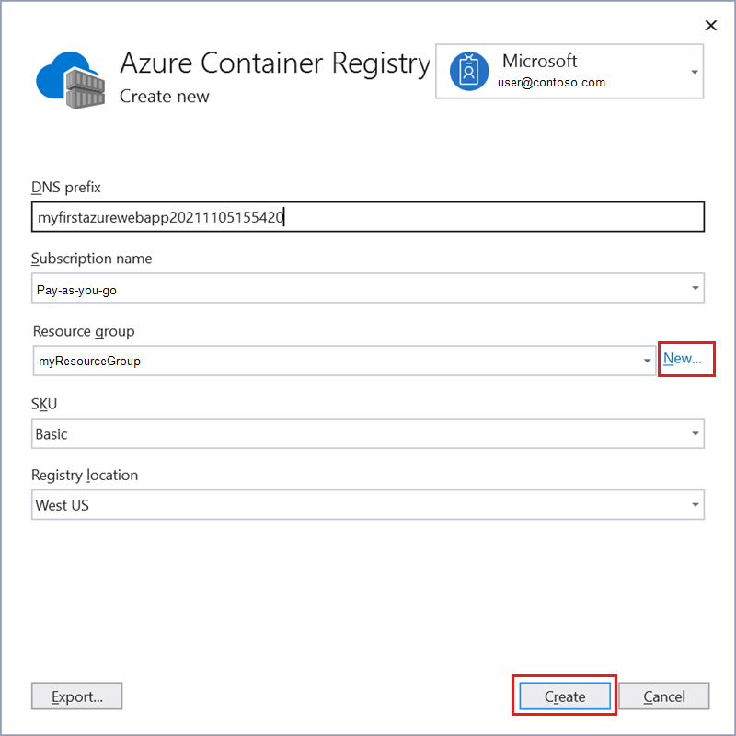

1. In **Publish**, under **Container Registry**, select the registry you created, and then select **Finish**.

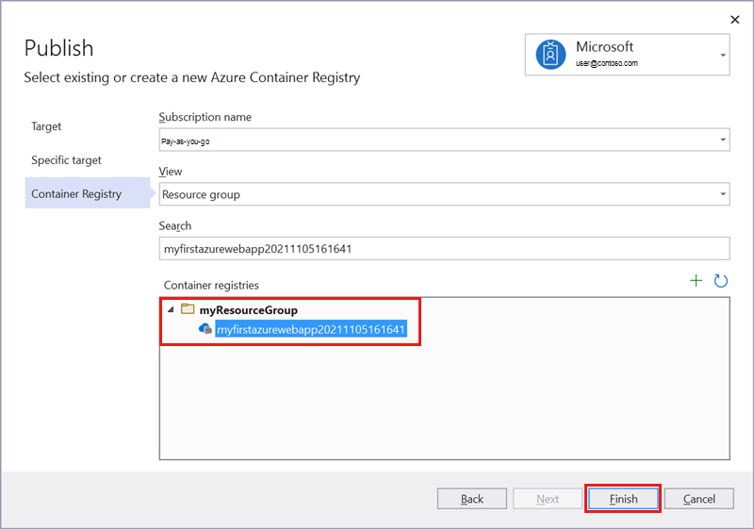

Wait for the deployment to complete. The **Publish** page now shows the repository name. Select the *copy button* to copy the **Repository** name for later.

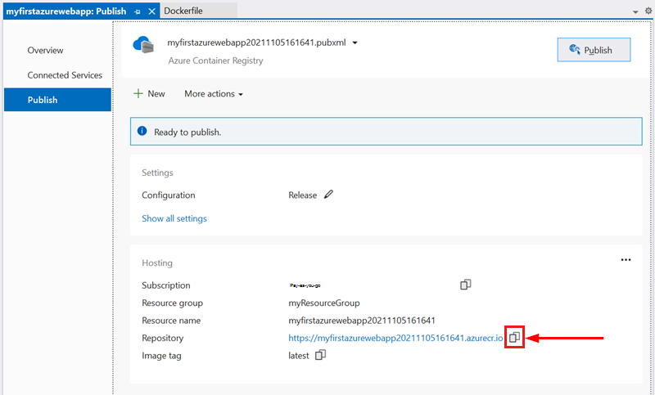

**Create a Windows custom container**

1. Sign in to the [Azure portal](https://portal.azure.com/).
2. Choose **Create a resource** in the upper left-hand corner of the Azure portal.
3. Under **Popular services**, select **Create** under **Web App**.
4. In **Create Web App**, choose your subscription and a **Resource Group**. You can create a new resource group if needed.
5. Provide an app name, such as *win-container-demo*. Choose **Docker Container** for **Publish** and **Windows** for **Operating System**. Select **Next: Docker** to continue.

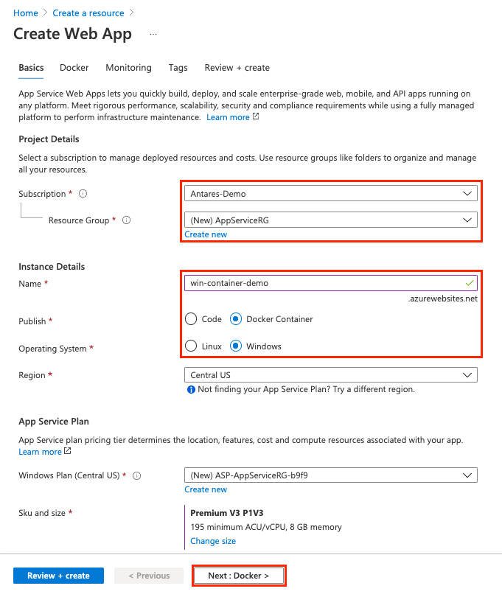

1. For **Image Source**, choose **Docker Hub** and for **Image and tag**, enter the repository name you copied in [Publish to Azure Container Registry](https://docs.microsoft.com/en-us/azure/app-service/quickstart-custom-container?tabs=dotnet&pivots=container-windows#publish-to-azure-container-registry).

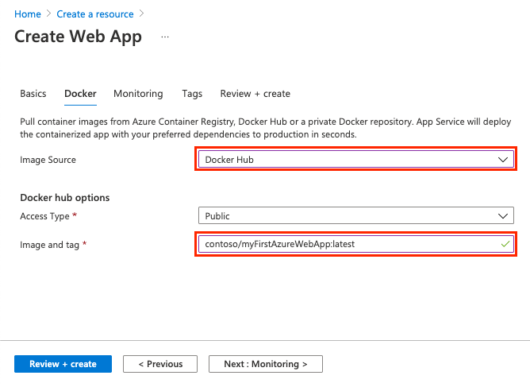

If you have a custom image elsewhere for your web application, such as in [Azure Container Registry](https://docs.microsoft.com/en-us/azure/container-registry/) or in any other private repository, you can configure it here.

1. Select **Review and Create** and then **Create** and wait for Azure to create the required resources.

**Browse to the custom container**

When the Azure operation is complete, a notification box is displayed.

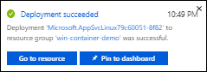

1. Click **Go to resource**.
2. In the overview of this resource, follow the link next to **URL**.

A new browser page opens to the following page:

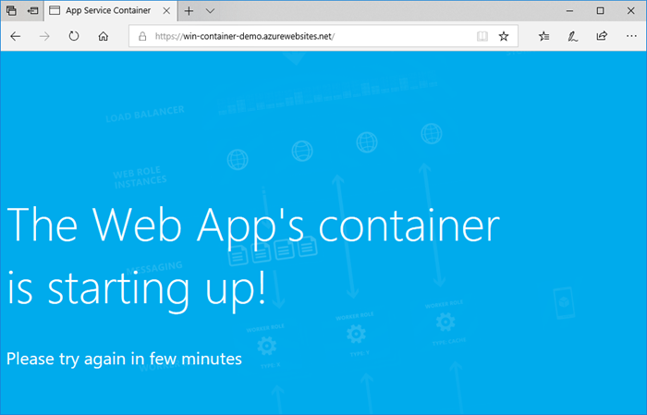

Wait a few minutes and try again, until you get the default ASP.NET home page:

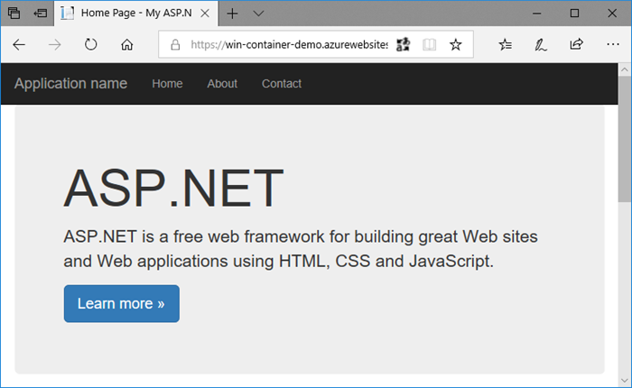

**Congratulations!** You're running your first custom Windows container in Azure App Service.

**See container start-up logs**

It may take some time for the Windows container to load. To see the progress, navigate to the following URL by replacing *<app_name>* with the name of your app.

Copy

https://<app_name>.scm.azurewebsites.net/api/logstream

The streamed logs looks like this:

Copy

2018-07-27T12:03:11 Welcome, you are now connected to log-streaming service.

27/07/2018 12:04:10.978 INFO - Site: win-container-demo - Start container succeeded. Container: facbf6cb214de86e58557a6d073396f640bbe2fdec88f8368695c8d1331fc94b

27/07/2018 12:04:16.767 INFO - Site: win-container-demo - Container start complete

27/07/2018 12:05:05.017 INFO - Site: win-container-demo - Container start complete

27/07/2018 12:05:05.020 INFO - Site: win-container-demo - Container started successfully

**Update locally and redeploy**

1. In Visual Studio, in **Solution Explorer**, open **Views** > **Home** > **Index.cshtml**.
2. Find the <div class="jumbotron"> HTML tag near the top, and replace the entire element with the following code:

HTMLCopy

<div class="jumbotron">

<h1>ASP.NET in Azure!</h1>

<p class="lead">This is a simple app that we've built that demonstrates how to deploy a .NET app to Azure App Service.</p>

</div>

1. To redeploy to Azure, right-click the **myfirstazurewebapp** project in **Solution Explorer** and choose **Publish**.
2. On the publish page, select **Publish** and wait for publishing to complete.
3. To tell App Service to pull in the new image from Docker Hub, restart the app. Back in the app page in the portal, click **Restart** > **Yes**.

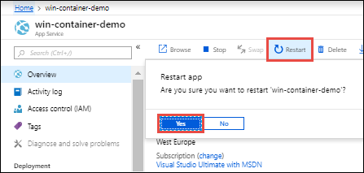

[Browse to the custom container](https://docs.microsoft.com/en-us/azure/app-service/quickstart-custom-container?tabs=dotnet&pivots=container-windows#browse-to-the-custom-container) again. As you refresh the webpage, the app should revert to the "Starting up" page at first, then display the updated webpage again after a few minutes.

